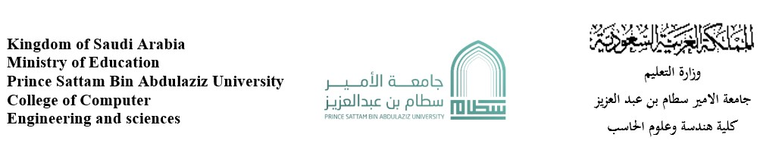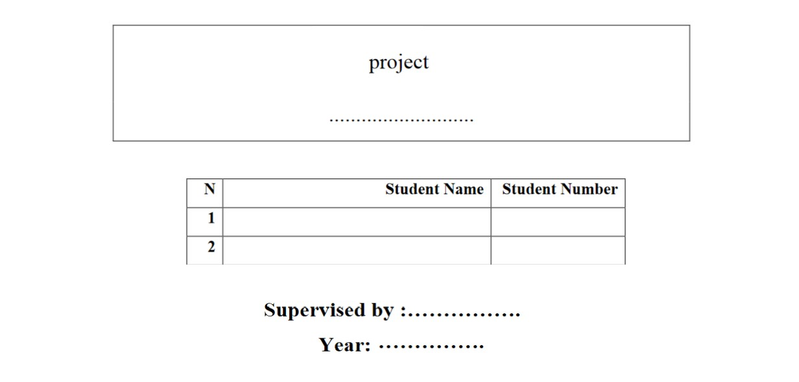

Twitter

|  |  |  |
| --- | --- | --- |
| N | Student name | Student Number |
| 1 | Abdulrhman fahd alhulil | 442051284 |
| 2 | Mohammed khalid alsheddi | 442050033 |
| 3 | Moath Othman al dauod | 443051005 |



Mohammed saad al-assiri

2023

1. Feasibility Study &Project Proposal

**Introduction**

A social media application that allows people to send texts, videos, photos, or even a group of tweets, is called a thread. Users of the program may post messages under the terms of the ethical policy. People can also follow each other and see the latest messages sent.

**Problems**

1- Difficulty receiving correct news from sources and communicating with society collectively.

2- The absence of platforms that allow the transfer of interest from experts clearly and directly.

3- The method of listening to past news was through newspapers, forums, or web pages.

4- There is no interactive platform for the community (a platform that allows short opinion polls or asking questions to the public).

**Solution**

Twitter has contributed to the ease of receiving news on one platform, the ease of talking with others, and the ability to read messages sent to the public, Twitter has helped share information in various fields from experts and third parties and the ability to publish information so that anyone can read it.

**Work plan**

Twitter plans to make the application serve public conversations and news and make it an important platform in the circulation of news I started by building Twitter for browsers with some features until I got to the mobile apps

Then they added features that helped make it easier to use the app and search faster under the so-called hashtags

Then they added broadcasts that contributed to making the content clear, and then started launching its latest features, which are the spaces that enable the creation of sessions composed of speakers and listeners, and added many of its features. After Elon musk acquired the app, he contributed to improving the usage and security policy.

**background**

The Twitter platform started in 2006 and has become one of the most popular communication applications. Its founders, Jack Dorsey, Noah Glass, Biz Stone, and Evan Wilmes, until selling it to Elon Musk in the past year 2022. Since the beginning of the launch of the program, it has achieved many records in 2012, achieving 100 million users and 340 million tweets.

1. Project requirements

**Functional requirements**

1. 1. Add a text box to write messages (tweets).
   1. The ability to write up to 280 characters per tweet.
   2. The ability to send media within tweets.
   3. The ability to retweet, and add likes and quotes.
   4. The ability to customize who can comment on the tweet.
   5. The ability to prevent non-added people from seeing tweets.
2. Add personal accounts section.
   1. The ability to modify the nickname at any time.
   2. The ability to modify the image and banner.
   3. The ability to view personal tweets and retweets.
   4. The ability to see who is following you and who you are following.
3. Add the Twitter search section.

3.1. design a section to search for accounts, tweets, or hashtags #.

3.2. design a section for hearings "space".

3.3. design a list of trending topics starting with the hashtag #.Add private messages section.

* 1. Create chat to send one to one messages.
  2. Create a groups containing users.

1. Add a section for notifications.
   1. Design a section for important messages and suggested news.
   2. View alerts outside the app.
   3. Design a button next to each account to activate the notification to notify the user of new news.

**Non-functional requirements**

1. Smooth use of the application and the flexibility of the streamlined presentation.
2. Make the program available for use at all times.
3. Enable two-factor authentication for a paid fee.
4. Implementation of program policy provisions and prohibition of profanity.
5. Availability of a large number of active users and ensuring the prevention of problems with the effectiveness of the application.
6. The speed of posting the tweet to the public.
7. Allocating a department for IT technical support.
8. Program design on Java, C++, Ruby, and MYSQL languages.

3. Activity diagram

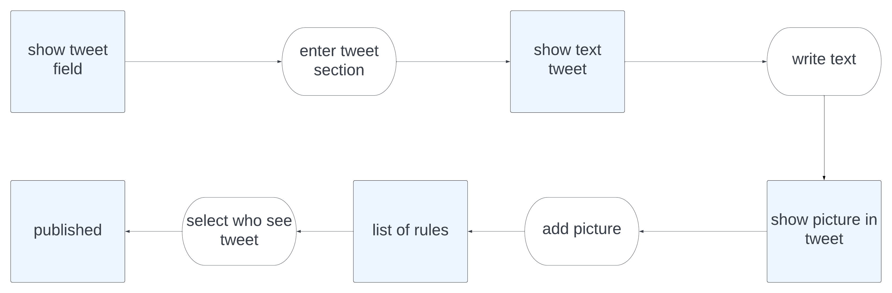

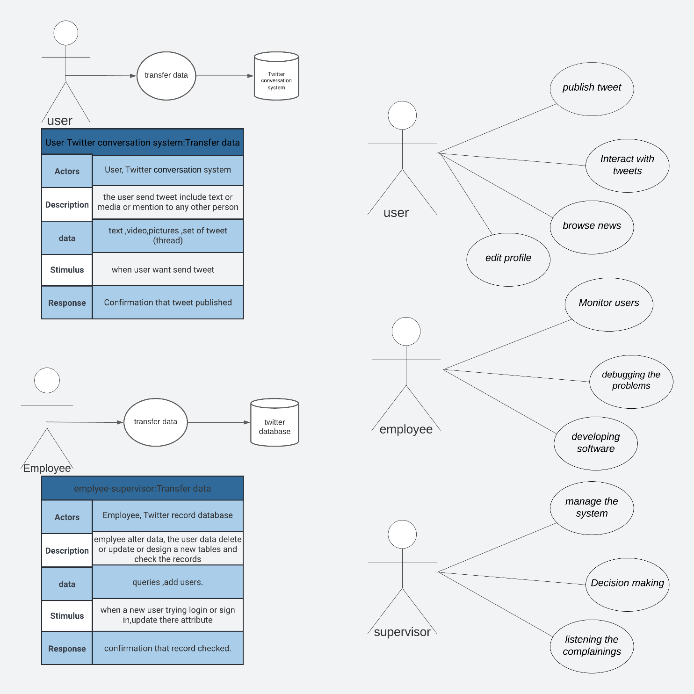  
4. Project Use Case Modelling

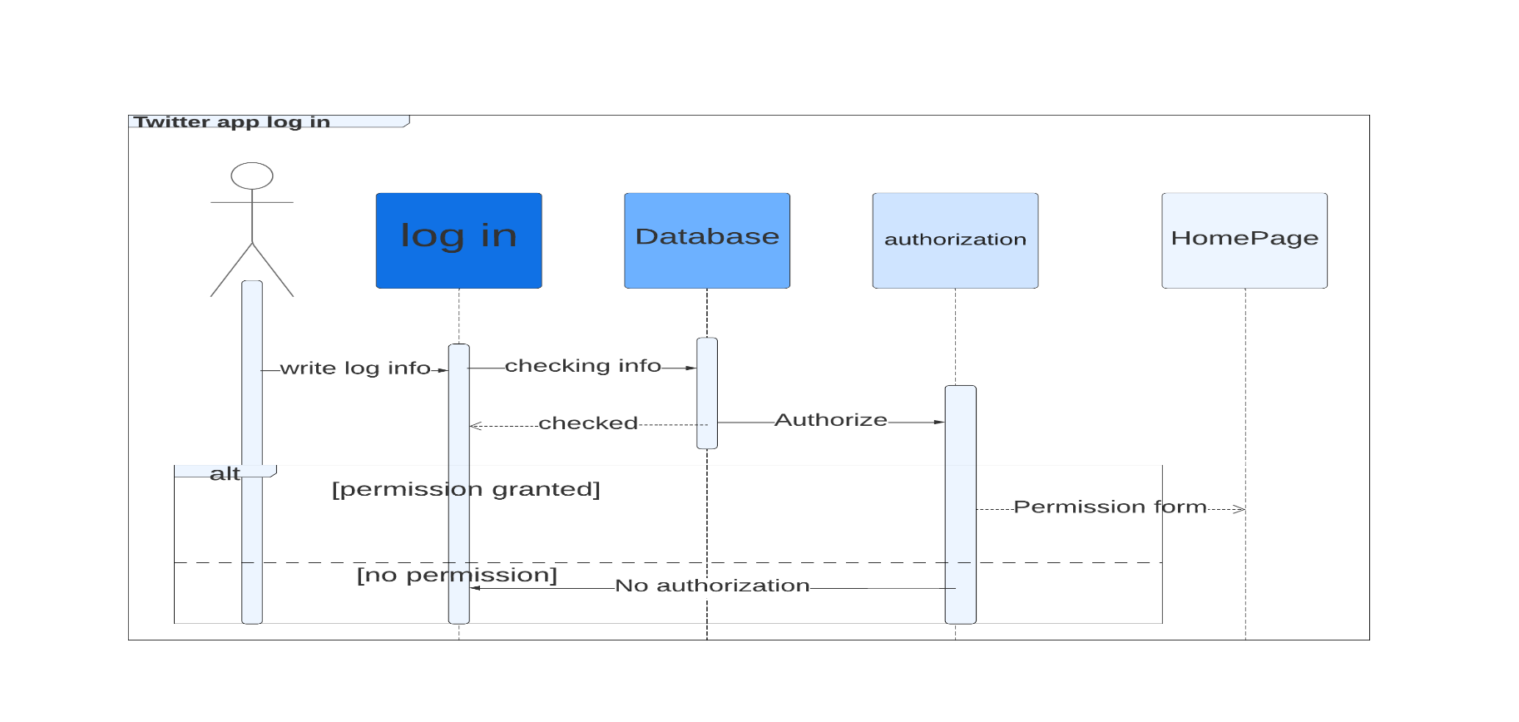  
5. Sequence Diagrams

1. 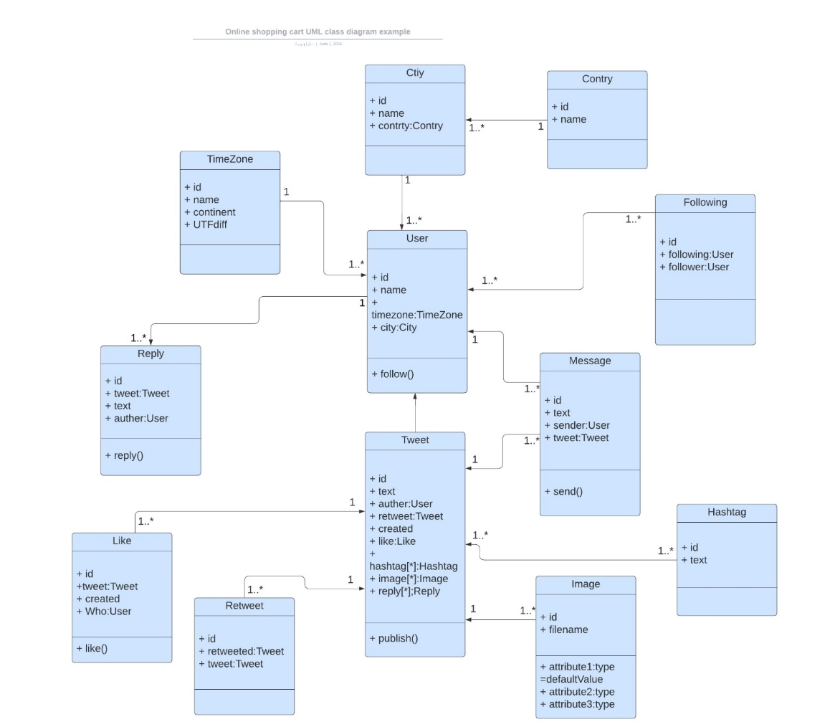User Interface Design

